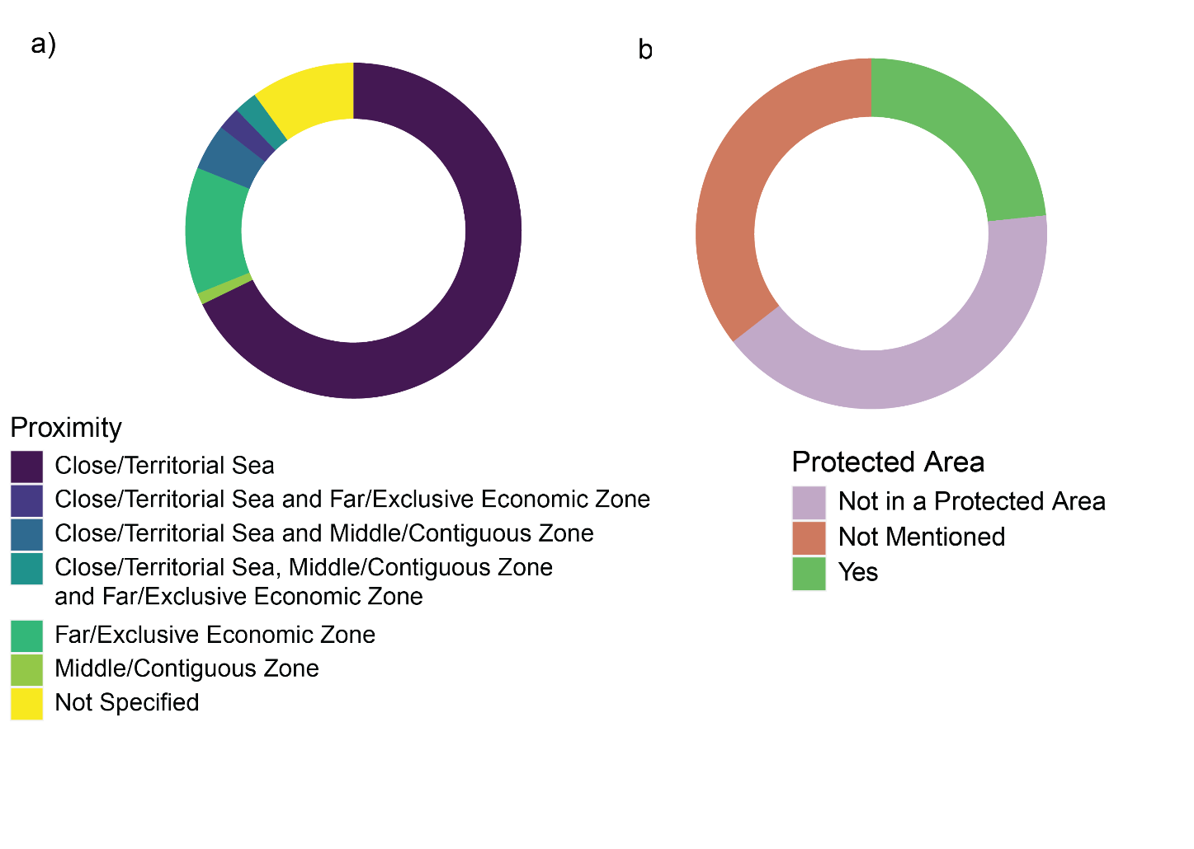

Figure 9 a) Donut plot showing the proximity of the locations of studies to the closest EEZ across all literature in this systematic map. b) Donut plot showing the proportions of studies that took place in a protected area.